* **Excel Lecture- 6**
* **INTRODUCTION TO POWER QUERY (GET AND TRANSFORM):**

= Available in Excel 2010,13,16

= Inbuilt in Excel 2016

🡪 Extract

🡪 Transform

🡪 Load

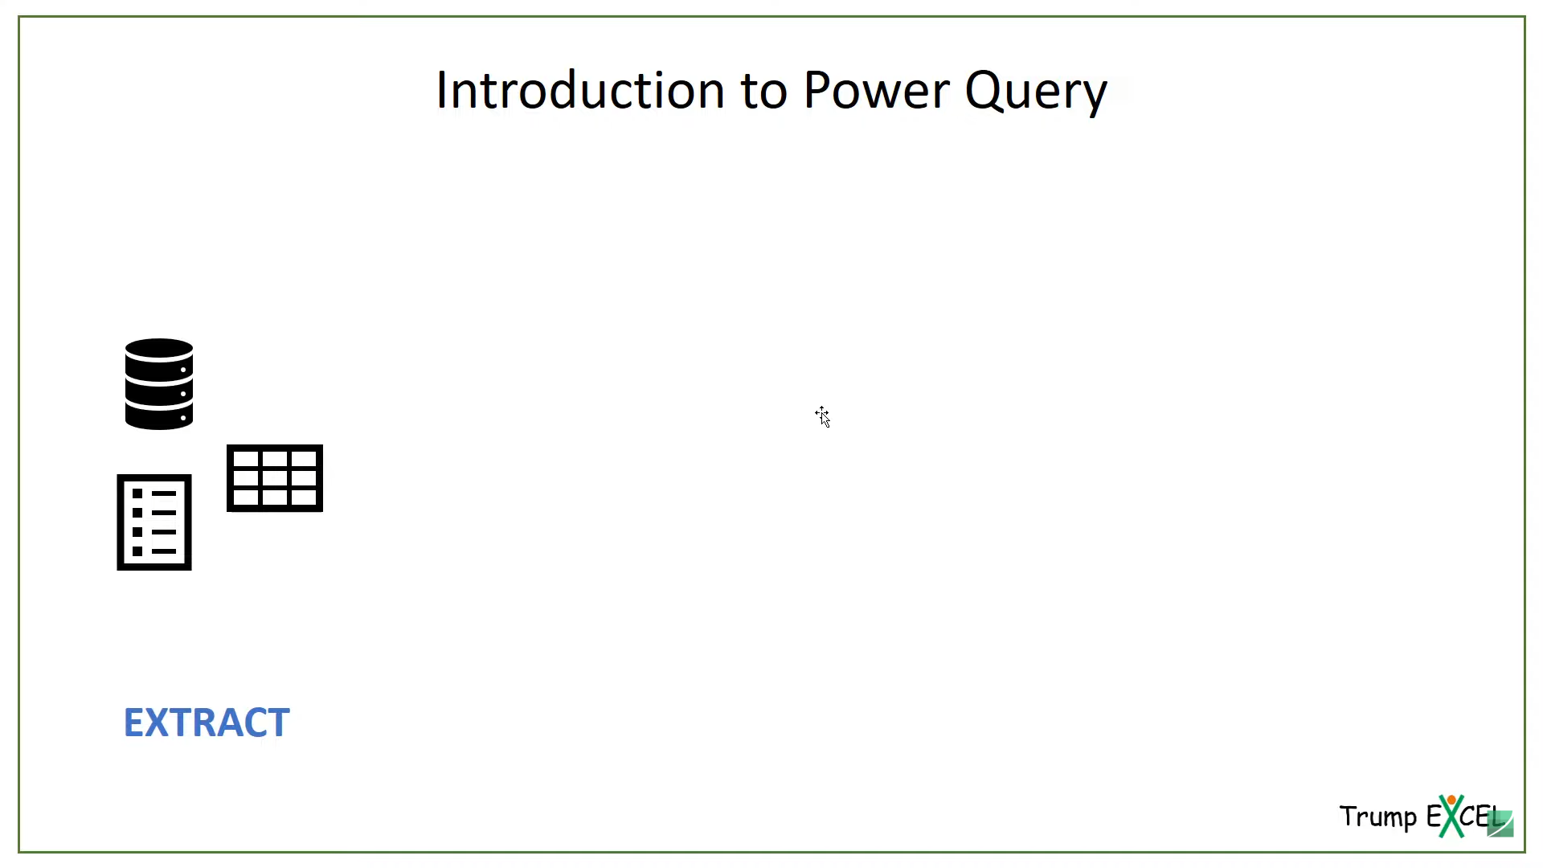

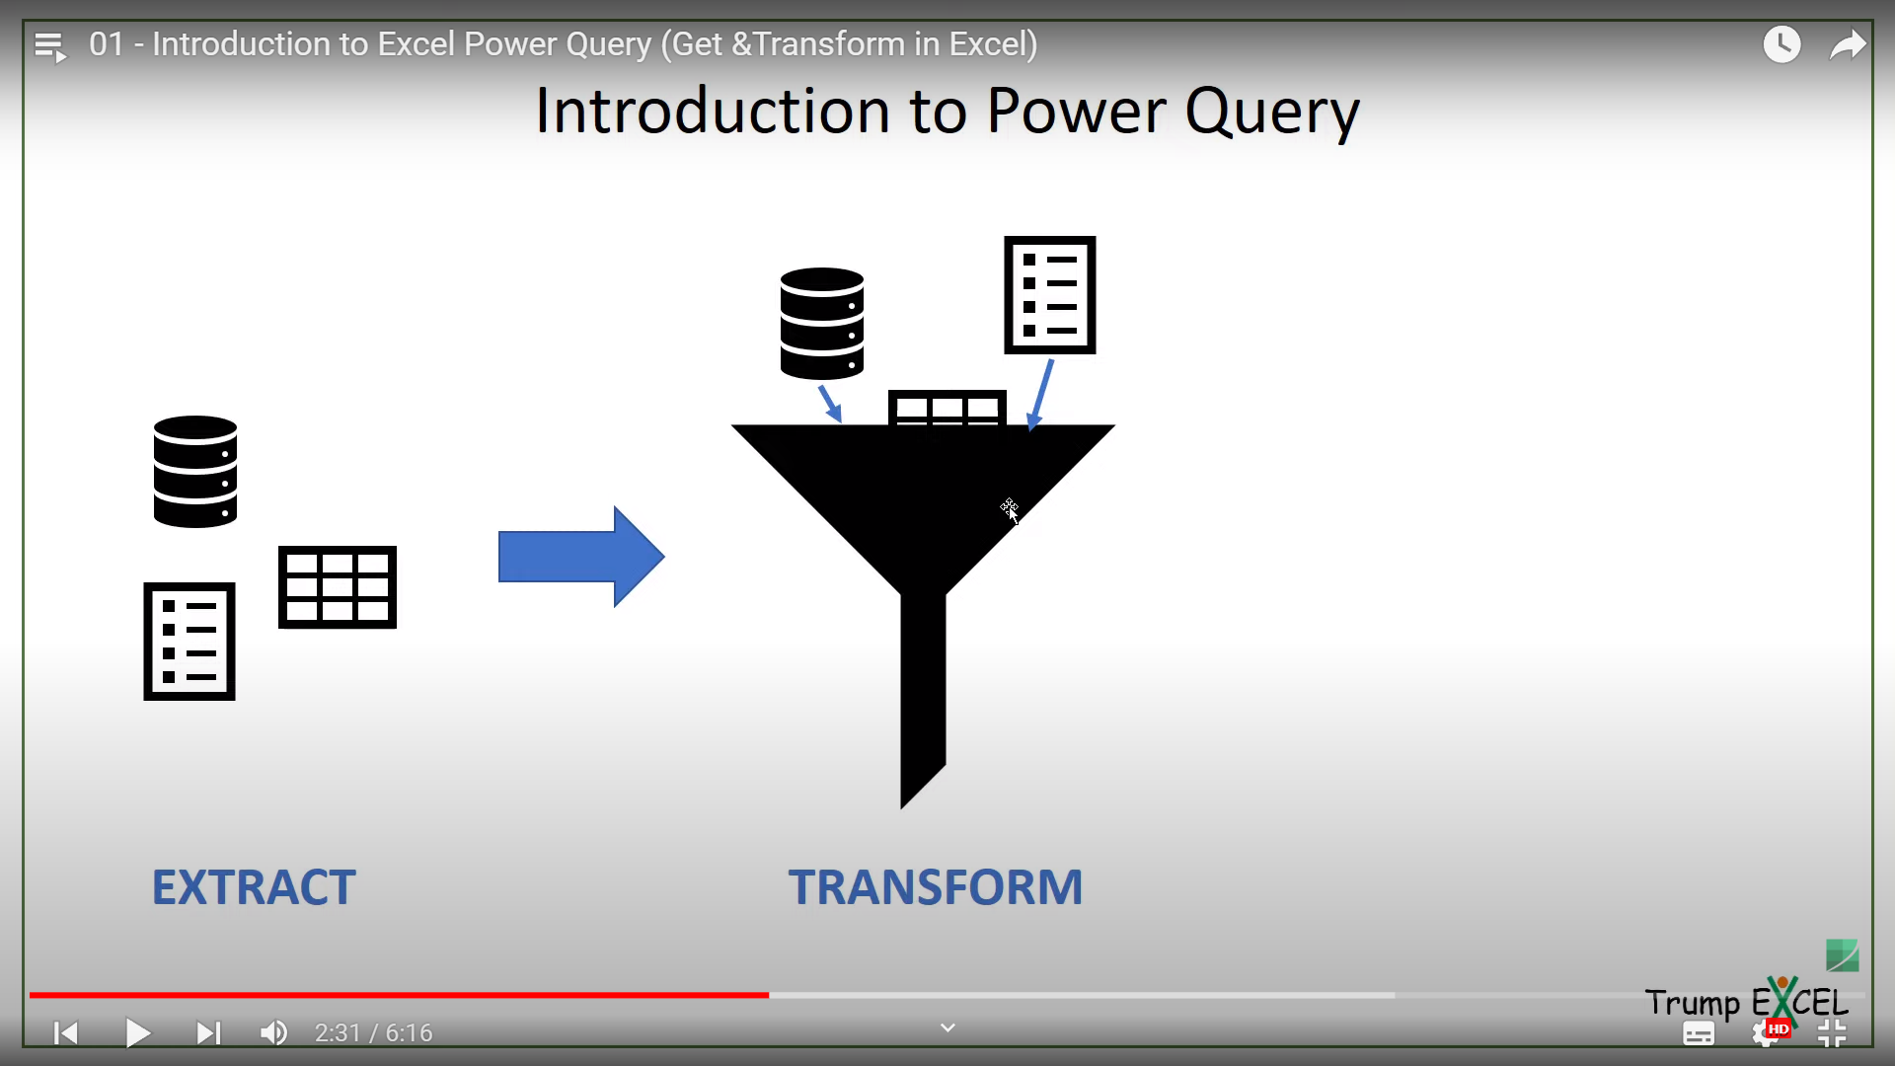

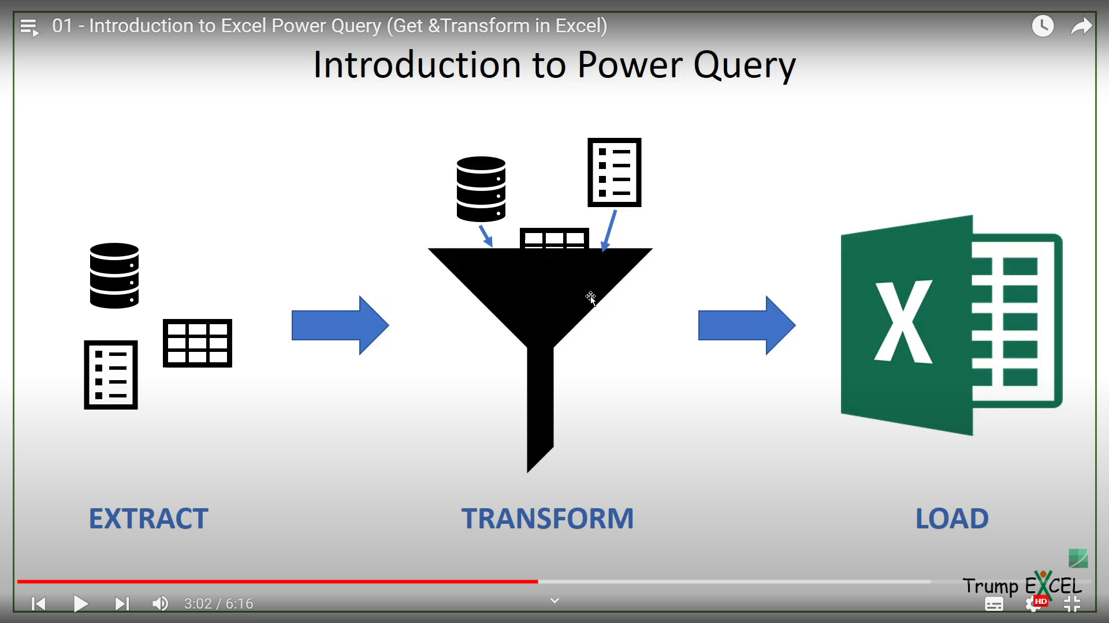

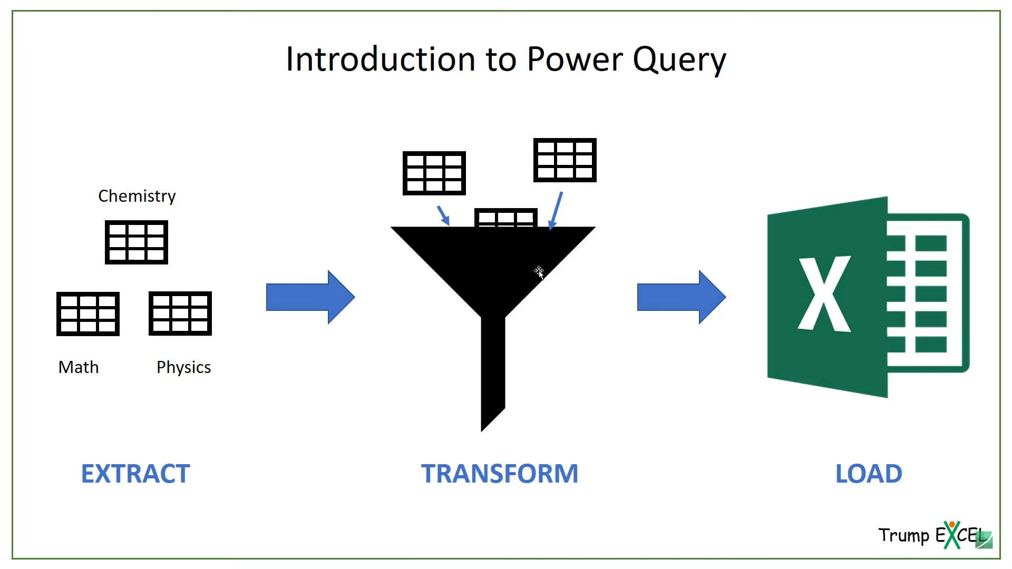

* **STEPS TO INSTALLING POWER QUERY (GET AND TRANSFORM):**

= Download Power Query Add in

= Goto Download

= select 32/64 bit

-Home 🡪 Options 🡪 Add in

* **Overview of Power Query:**

= Query Editor 🡪get data 🡪from other sources 🡪Blank Query